BEL ENTERPRISE CODIFICATION &
PROJECT MANAGEMENT SYSTEM

ABSTRACT
Modern defense manufacturing and production enterprises like Bharat Electronics Limited (BEL) necessitate highly rigid data standardization architectures, absolute auditability, and granular tracking frameworks to maintain operational security and engineering precision. The BEL Enterprise Codification & Project Management System is an enterprise-scale web application developed using the Model-View-Controller (MVC) paradigm to unify item codification (Item Nomenclature Codification – INC), project tracking, lifecycle verification, and rigorous role-based validation matrices.
Built over a secure runtime environment of Node.js and Express.js, with a normalized MySQL relational backend, the platform transitions manual spreadsheet-driven engineering workflows into an integrated transaction layer. The application handles multi-tiered authorizations (Administrator, Engineer, Approver, and Employee), embedding structural mechanisms for Bill of Materials (BOM) construction, drawing revision control, vendor evaluation logs, and comprehensive cryptographic audit trailing via bcryptjs and Express Session.
Advanced reporting modules powered by Chart.js, DataTables, and server-side streaming engines enable rapid extraction of analytical visualizations and verified exports via Excel and PDF. By combining rigid item serialization with structured project workflows, the system mitigates component duplication, ensures full supply-chain traceability, and guarantees total operational alignment with corporate security frameworks.

TABLE OF CONTENTS

Ch. No. | Chapter Name | Page No.
1 | Cover Page | 1
2 | Certificate | 2
3 | Declaration | 3
4 | Acknowledgement | 4
5 | Abstract | 5
6 | Table of Contents | 6
7 | Introduction | 7
8 | Company Profile (BEL) | 8
9 | Problem Statement | 9
10 | Existing System | 10
11 | Proposed System | 11
12 | Objectives | 12
13 | Scope | 13
14 | Software Requirements | 14
15 | Hardware Requirements | 15
16 | Technology Stack | 16
17 | System Architecture | 17
18 | Database Design | 18
19 | ER Diagram | 19
20 | DFD Level 0 | 20
21 | DFD Level 1 | 21
22 | Use Case Diagram | 22
23 | Class Diagram | 23
24 | Activity Diagram | 24
25 | Sequence Diagram | 25
26 | Authentication Module | 26
27 | Dashboard Module | 27
28 | INC Module | 28
29 | Project Management Module | 29
30 | Vendor Module | 30
31 | Drawing Module | 31
32 | Document Module | 32
33 | Search Module | 33
34 | Reports Module | 34
35 | Audit Module | 35
36 | Notifications | 36
37 | Security Features | 37
38 | API Design | 38
39 | Frontend Design | 39
40 | Backend Design | 40
41 | Testing | 41
42 | Test Cases | 42
43 | Results | 43
44 | Advantages | 44
45 | Limitations | 45
46 | Future Scope | 46
47 | Conclusion | 47
48 | References | 48
49 | Appendix | 49

7. INTRODUCTION
In massive manufacturing ecosystems, specifically within strategic defense sectors, data standardisation stands as a core pillar governing efficiency, engineering precision, and security compliance. A lack of standardisation in part naming, sub-assembly categorization, and component specifications invariably gives rise to redundant inventory tracking, misaligned procurement processes, and high operational inefficiencies. The process of mapping, naming, categorizing, and issuing unique identification codes to individual structural elements is termed Item Nomenclature Codification (INC).
The BEL Enterprise Codification & Project Management System is built specifically to address these challenges inside a multi-department defense ecosystem. Operating on a robust Model-View-Controller architecture built using Node.js, Express.js, and MySQL, the application acts as a single centralized transaction registry. It systematically ensures that every component manufactured or procured by the enterprise is explicitly registered via a multi-level taxonomy, bound directly to specific strategic projects, checked against cross-department structural revisions, and monitored via strict cryptographic authorization mechanisms.

8. COMPANY PROFILE (BEL)
Bharat Electronics Limited (BEL) is a premier multi-technology, multi-unit Navratna Public Sector Undertaking under the Ministry of Defence, Government of India. Established in 1954 in collaboration with CSF of France to fulfill the country's strategic electronic requirements, BEL has evolved into a key supplier of advanced electronic equipment for the Indian Armed Forces, covering Radar systems, Missile systems, Sonar networks, Electronic Warfare suites, and Tactical Communication platforms.
Operating across 9 state-of-the-art manufacturing facilities throughout India, BEL manages tens of thousands of complex engineering drawings, mechanical assemblies, and vendor pipelines daily. Given the critical nature of its products, strict security standards, comprehensive audit trailing, and highly normalized component codification rules are essential across all operational layers. This system provides a conceptual design tailored to these exact requirements, helping streamline information flow and prevent data fragmentation.

9. PROBLEM STATEMENT
The operational workflows at multi-unit defense production centers face significant tracking challenges due to data fragmentation. In the absence of an integrated codification matrix, individual engineering teams often utilize distinct spreadsheet schemas to document incoming hardware components, electrical sub-units, and physical raw items. This lack of centralized alignment causes several critical issues:
- Component Duplication: The same identical electrical transistor or mechanical bracket may be assigned different localized names across separate units, leading to duplicate procurement orders and inflated component inventory costs.
- Untraceable Revisions: Engineering blueprints and structural CAD designs undergo periodic modifications without automatic cross-referencing against the primary Bill of Materials (BOM), leading to outdated designs being mistakenly sent to production floors.
- Security and Verification Gaps: Document distributions, vendor assignment approvals, and product codification releases are handled via legacy physical signatures or untracked email interactions, resulting in a lack of clean, time-stamped audit trails for accountability.

10. EXISTING SYSTEM
The legacy operational model depends heavily on decentralized Microsoft Excel worksheets updated locally across different engineering, procurement, and verification departments, alongside manual routing of physical approval files. The data validation flow operates as follows:
Workflow Stage | Existing Process Mechanism | Primary Operational Bottleneck
Item Registration | Manual entry in isolated local departmental Excel sheets. | High frequency of naming variations and duplicate registrations.
Drawing Management | Shared network file storage with manual folder version tagging (e.g., v1, v2_final). | No systematic lock mechanism; high risk of overwriting active design versions.
Verification & Approval | Physical signing of inter-departmental forms and manual internal mailing. | Significant turnaround delays and lack of digital transparency.

11. PROPOSED SYSTEM
The proposed BEL Enterprise Codification & Project Management System establishes a single web-based transactional platform governed by a centralized relational database schema. By transitioning all data entries into structured SQL tables validated by an MVC engine, the platform introduces automated entry checks, uniform codification structures, and granular transaction logging.
Every structural drawing, engineering revision, vendor allocation, and item assignment is explicitly tracked within a tamper-proof audit trail. The application eliminates localized data silos by implementing custom dashboards optimized for distinct user clearance levels (Administrator, Engineer, Approver, and Employee). It enforces an isolated, digital approval matrix that requires authorized electronic validation before an item can be successfully updated in the master repository.

12. OBJECTIVES
The target operational goals for the designed enterprise system are defined below:
- Standardized Enterprise Codification: Enforce a strict multi-tiered numeric structural layout for every engineering item to ensure complete data uniformity.
- Real-time Project Tracking: Centralize project milestones, baseline schedules, and current task metrics on a single high-performance visual dashboard.
- Automated Revision Controls: Connect CAD files and drawing uploads directly to the primary database, keeping a clear history of active versions.
- Granular Security Tracking: Log every system query, user login, file generation, and record update inside a secure, unalterable system log table.

13. SCOPE
The operational boundaries of this application encompass the core internal workflows of BEL engineering divisions, project management offices, and procurement validation units. The platform covers the full product development lifecycle — from the initial creation of an INC entry through drawing version controls, vendor verification checks, and final document release workflows.
The application is designed specifically for internal network deployments within an enterprise Intranet environment, ensuring strict security separation from public web vectors. It does not integrate external financial accounting modules or public-facing customer interfaces, focusing entirely on secure corporate item codification and project control mechanisms.

14. SOFTWARE REQUIREMENTS
Component Category | Software Application / Package Specification | Deployment Role
Operating System | Ubuntu Server 22.04 LTS / Windows Server 2022 | Base Server Environment Architecture
Runtime Environment | Node.js Engine Runtime v18.16.0 LTS or higher | Server-Side Logic Execution Environment
Web Application Server | Express.js Framework v4.18.2 | HTTP Request Routing and Middleware Controller
Database Engine | MySQL Community Server v8.0.33 | Structured Relational Storage Backend Layer
UI Core Framework | Bootstrap CSS Layout Toolkit v5.3.0 | Responsive Client Interfaces

15. HARDWARE REQUIREMENTS

15.1 Production Server Specifications
- Processor Type: Intel Xeon Scalable Processor (Minimum 8 Physical Cores, 2.5 GHz clock speed).
- System RAM: 32 GB DDR4 ECC Enterprise Grade Memory.
- Storage Units: 1 TB NVMe SSD configured in a RAID 1 array for data redundancy.
- Network Interfaces: Dual Gigabit Ethernet Ports (10/100/1000 Mbps capacity).

15.2 Client Workstation Specifications
- Processor Architecture: Intel Core i5 or AMD Ryzen 5 processor.
- System RAM: 8 GB DDR4 System RAM.
- Display Interface: Full HD Display Monitor (1920x1080 resolution support).

16. TECHNOLOGY STACK
The platform relies on a collection of modern, stable development frameworks chosen to maximize request throughput, secure enterprise-level operational tracking, and maintain strict data consistency across all tables:
- Node.js & Express.js: Utilizes a non-blocking, asynchronous event loop to handle concurrent user requests efficiently, providing clean routing and middleware management.
- MySQL Database: Provides a robust relational architecture supporting ACID-compliant transactions, foreign key constraints, and performance-optimized multi-table joins.
- Bootstrap 5 & JavaScript: Provides a responsive user interface that scales cleanly across multiple enterprise devices without requiring extensive browser plugins.
- DataTables & Chart.js: Formats complex row sets with client-side searching and sorting capabilities, accompanied by clear canvas-based data visualizations.
- Express Session & bcryptjs: Handles session state securely using server-side cookie signatures, while applying cryptographic hashing to user credentials before persistence.

17. SYSTEM ARCHITECTURE
The application is designed around the classic Model-View-Controller (MVC) architectural pattern, separating the data persistence layers, user interface elements, and request processing logic into clean, independent modules. This structure prevents tight coupling between the user interface and underlying database schemas.
When an engineer initiates an item query or file upload, the request passes through the Express session validation routing layer. Once authorized, the appropriate Controller queries the data model using highly optimized MySQL connections. The retrieved dataset is then formatted into HTML templates or JSON data streams before being returned to the client browser.
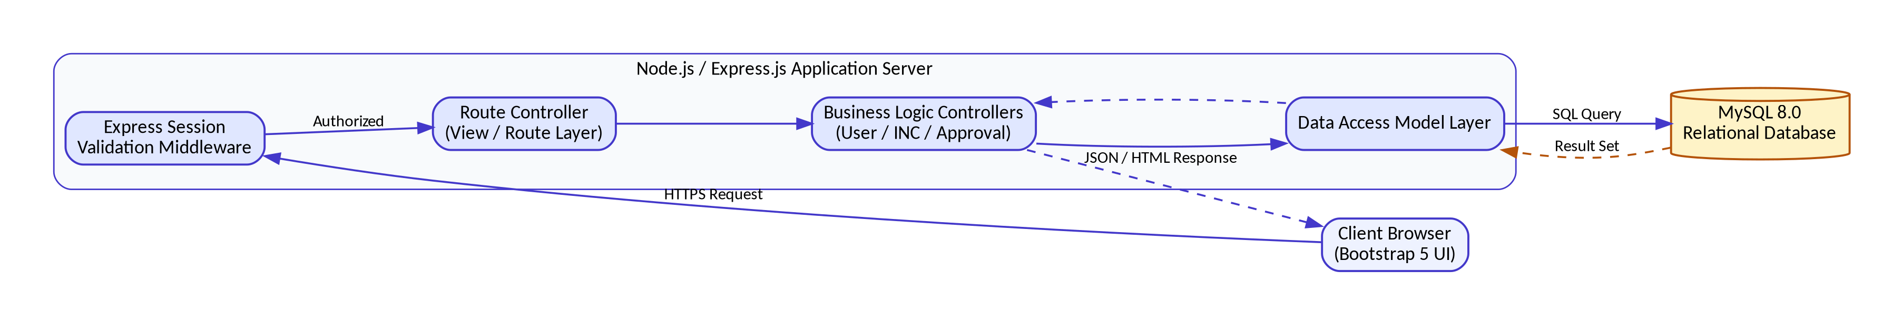
Fig. 17.1 — System Architecture: MVC Request Flow to MySQL Database Instance

18. DATABASE DESIGN
The storage schema is organized using fully normalized structural relationships to eliminate data redundancy and preserve complete operational tracking integrity. Key table schemas are detailed below:

Table 1: users
Field Name | Data Type | Constraints | Functional Description
user_id | INT | PRIMARY KEY, AUTO_INCREMENT | Unique corporate identification sequence.
username | VARCHAR(50) | UNIQUE, NOT NULL | Enterprise active directory username string.
password_hash | VARCHAR(255) | NOT NULL | Cryptographic representation generated by bcryptjs.
role_id | INT | FOREIGN KEY references roles | Link to application permission clearance level.
dept_id | INT | FOREIGN KEY references departments | Internal structural division reference indicator.

Table 2: inc_master
Field Name | Data Type | Constraints | Functional Description
inc_id | INT | PRIMARY KEY, AUTO_INCREMENT | Internal index identifier.
codification_code | VARCHAR(30) | UNIQUE, NOT NULL | Standardized multi-level identification key.
item_nomenclature | VARCHAR(150) | NOT NULL | Standardized item naming string.
project_id | INT | FOREIGN KEY references projects | Associated technical project tracking index.
approval_status | ENUM | 'Pending','Approved','Rejected' | Current item lifecycle verification stage.

Table 3: audit_logs
Field Name | Data Type | Constraints | Functional Description
log_id | BIGINT | PRIMARY KEY, AUTO_INCREMENT | Unique sequence number for system logs.
user_id | INT | FOREIGN KEY references users | The engineer executing the transaction.
action_performed | VARCHAR(100) | NOT NULL | Descriptive string mapping the executed task.
ip_address | VARCHAR(45) | NOT NULL | Network origin tracking string.
timestamp | TIMESTAMP | DEFAULT CURRENT_TIMESTAMP | Unmodifiable operational event clock.

19. ENTITY RELATIONSHIP (ER) DIAGRAM
The ER Diagram maps the database structure, showing how users connect to structural permissions, project items connect to bill of materials (BOM), and change requests feed into the audit trails.
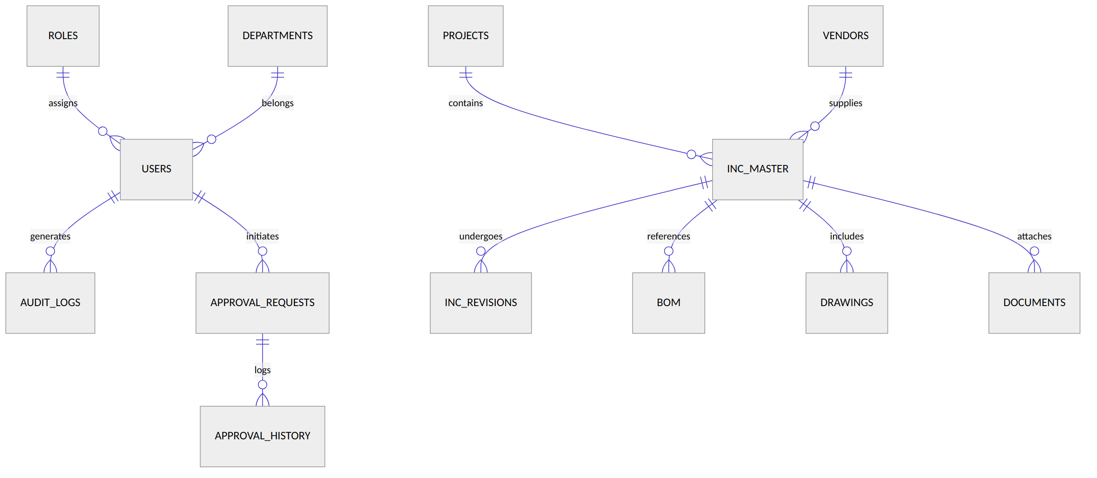
Fig. 19.1 — Entity Relationship Diagram

20. DATA FLOW DIAGRAM (DFD) LEVEL 0 — CONTEXT DIAGRAM
The Context Diagram presents the application boundary, highlighting the information exchange between authorization groups and the core enterprise system.
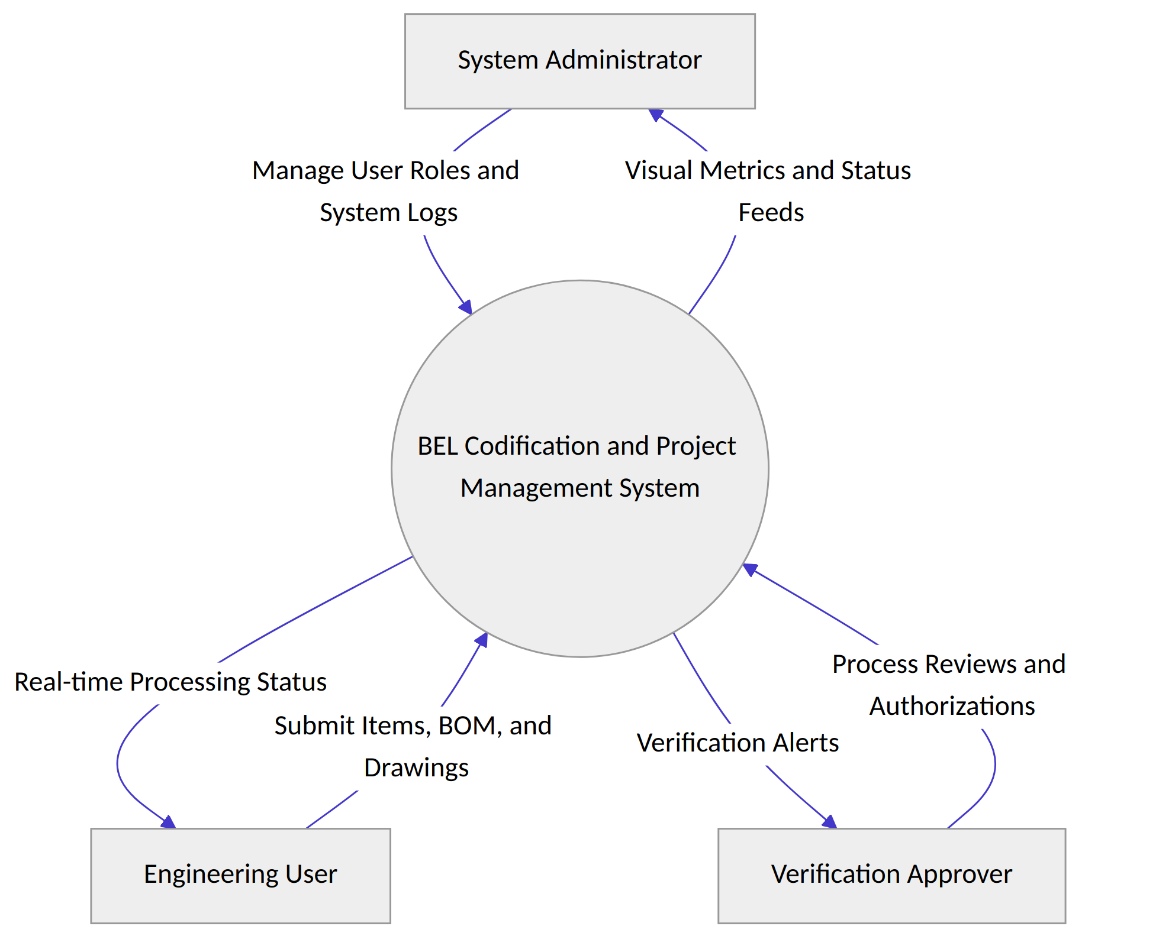
Fig. 20.1 — DFD Level 0 (Context Diagram)

21. DATA FLOW DIAGRAM (DFD) LEVEL 1 — PROCESS BREAKDOWN
The Level 1 breakdown details data flows across core system features, including login verification, item processing, drawing tracking, and report production.
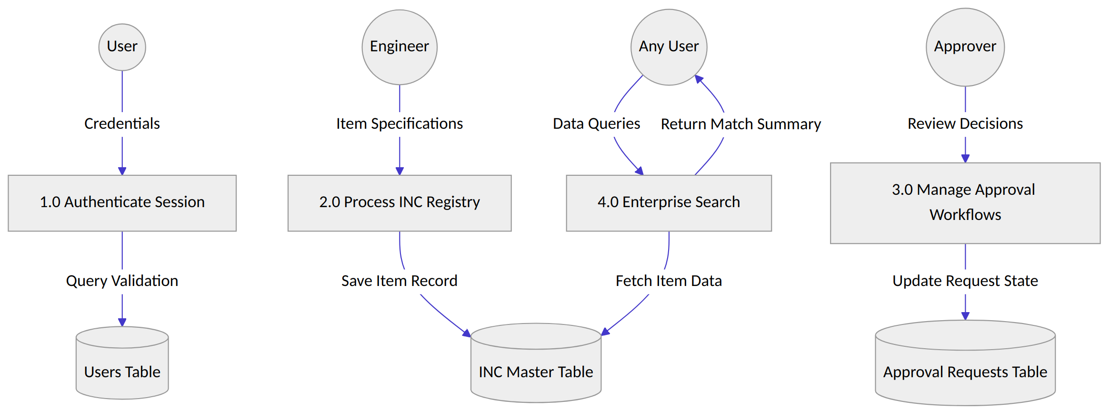
Fig. 21.1 — DFD Level 1 (Process Breakdown)

22. USE CASE DIAGRAM
The Use Case structure separates permissions into distinct access paths, keeping high-level operational metrics restricted to administrators and structural entry forms limited to engineering teams.
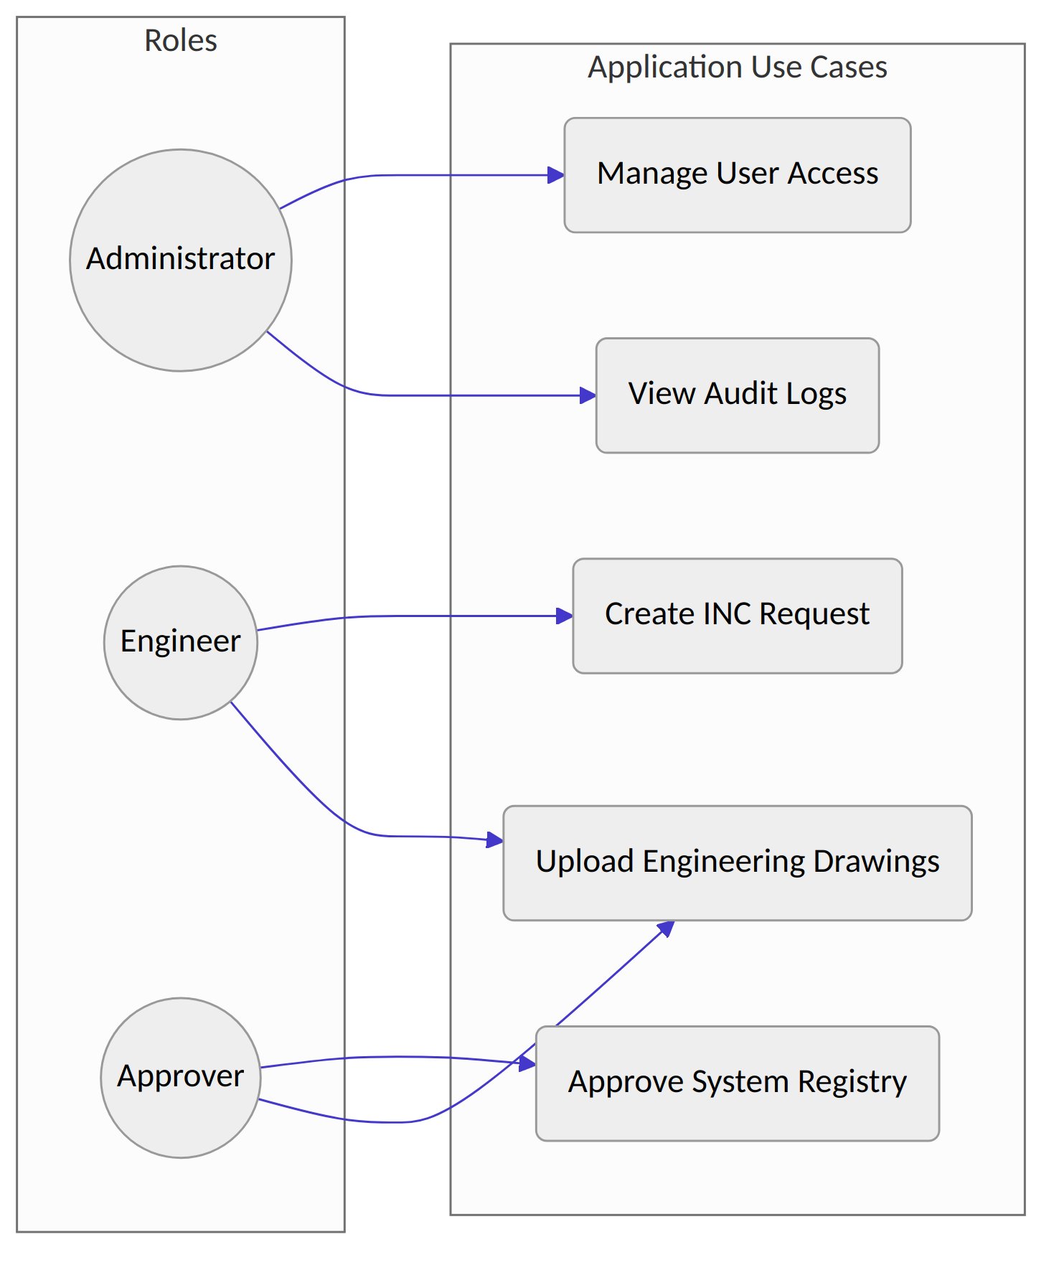
Fig. 22.1 — Use Case Diagram

23. CLASS DIAGRAM
The logical Class architecture matches the application's MVC layout, connecting database tables to active controllers that process user input and format the final interface views.
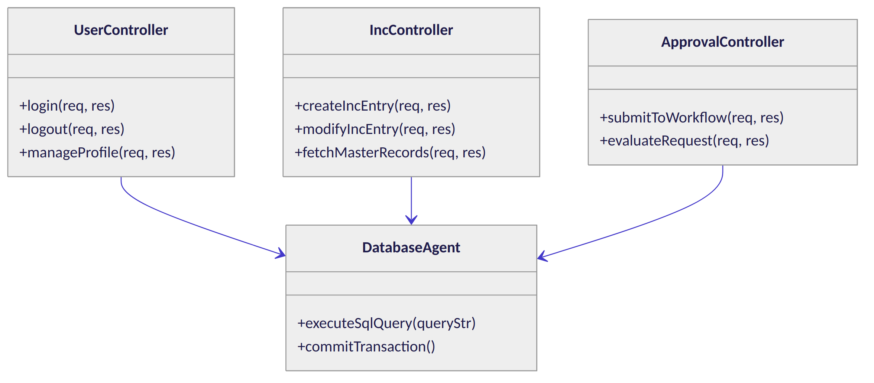
Fig. 23.1 — Class Diagram

24. ACTIVITY DIAGRAM
The Activity layout tracks an item's path through the system, starting with the initial entry checks by engineers, running through the modification reviews, and ending with its final inclusion in the master data warehouse.
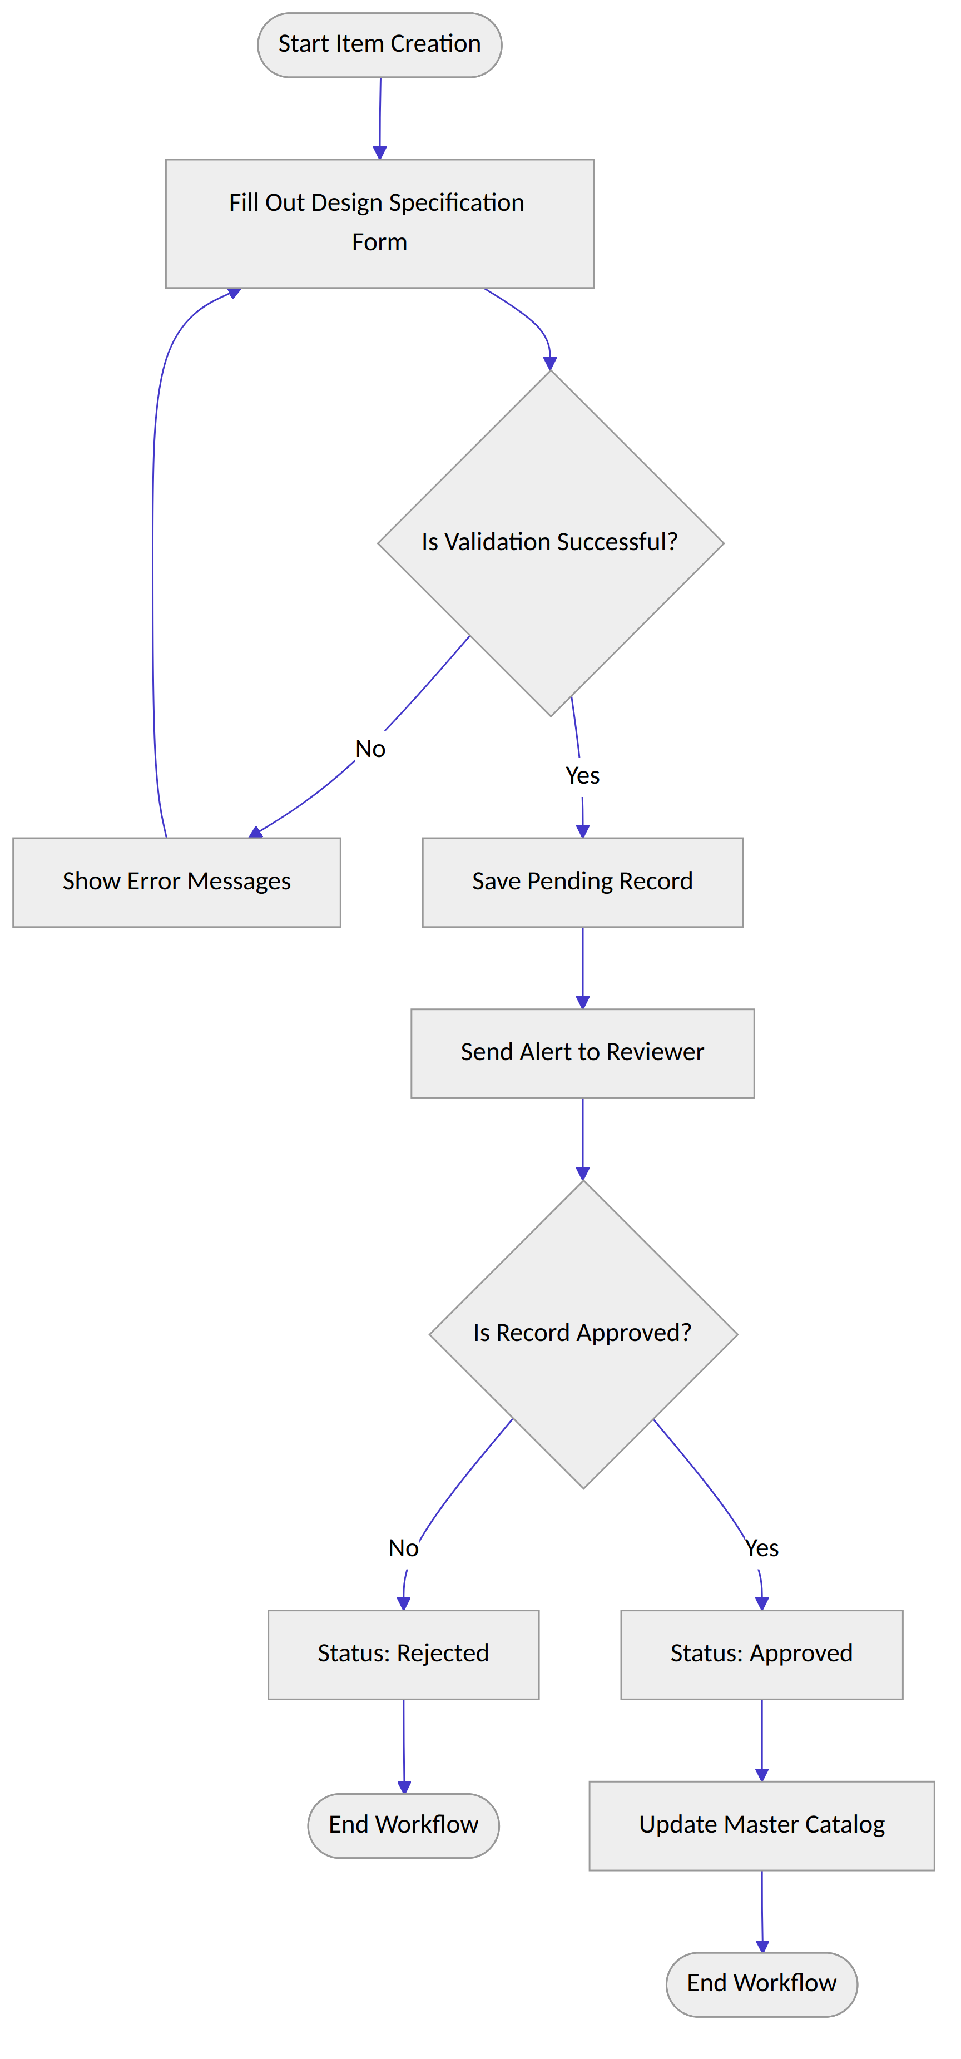
Fig. 24.1 — Activity Diagram

25. SEQUENCE DIAGRAM
The Sequence Diagram displays the interaction timeline among the browser, the MVC controllers, the validation middleware, and the underlying MySQL data tables.
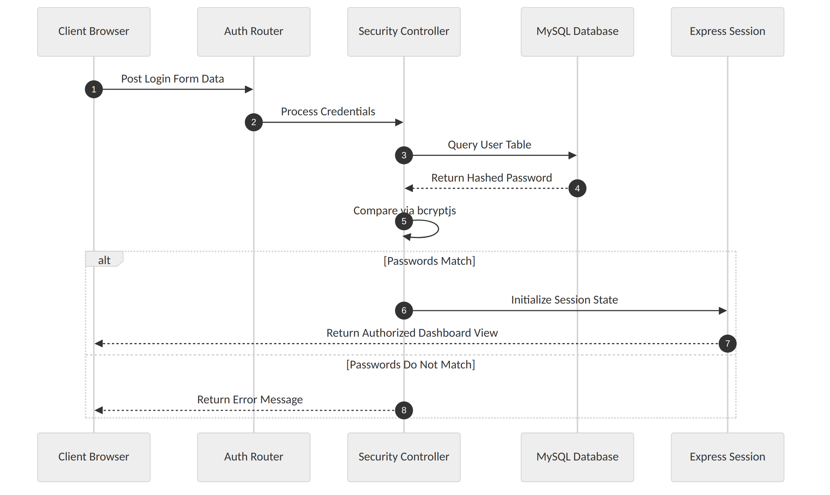
Fig. 25.1 — Sequence Diagram: Login & Authentication Flow

26. AUTHENTICATION MODULE
The Authentication module provides the primary security barrier for the system. It handles credential validation, tracks active user sessions, and blocks unauthorized route access across all data layers.
The module uses a secure cryptographic workflow: user passwords are processed using a salt work factor of 10 through the bcryptjs library. Active session states are maintained on the server and verified via signed browser cookies using the Express Session middleware, preventing session hijacking attempts.
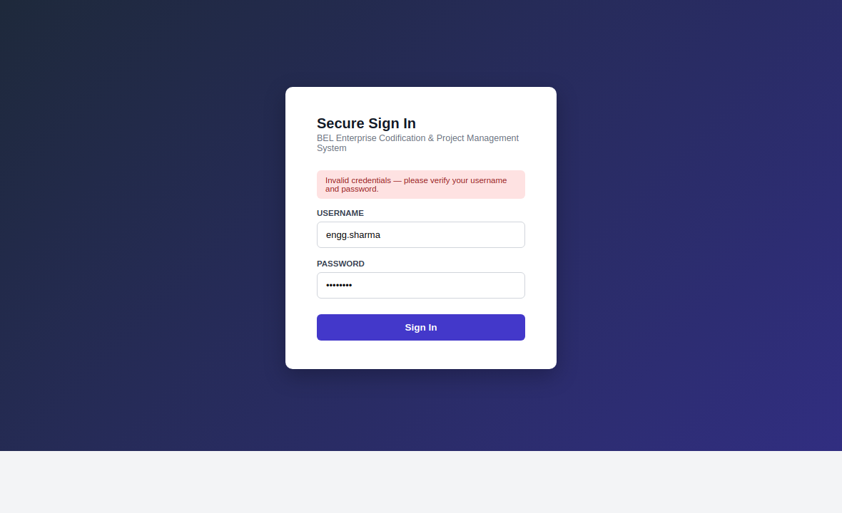
Fig. 26.1 — Secure Login Interface (Username and Password Fields with Validation State)

27. DASHBOARD MODULE
The Dashboard module acts as the primary analytical control panel for users, displaying customized metrics and toolsets based on individual role assignments.
The interface uses Chart.js for dynamic client-side visualizations and DataTables for flexible row sorting. System administrators see user activity metrics, while engineers are presented with item validation queues and current project progress indicators.
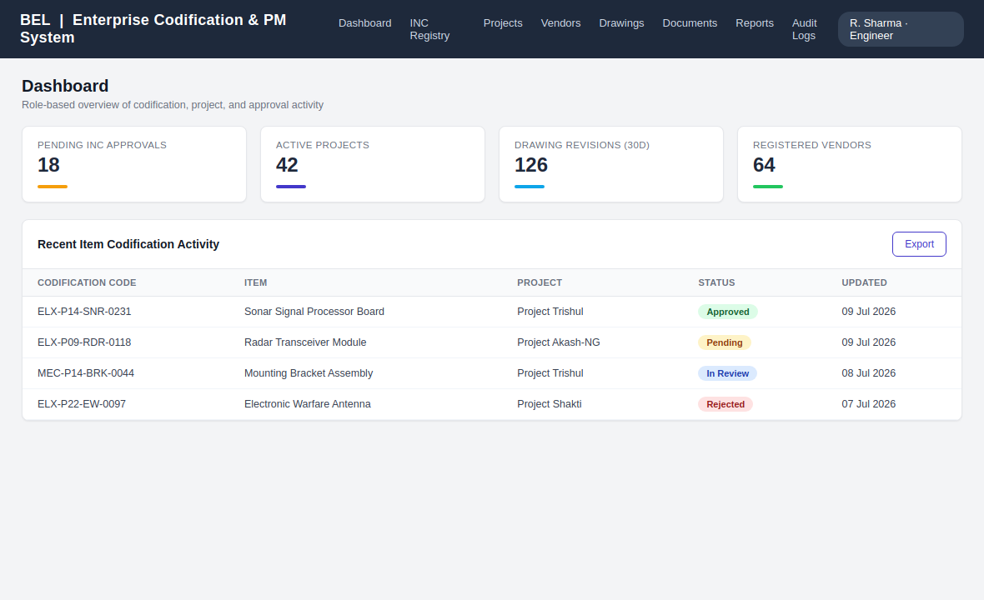
Fig. 27.1 — Main Analytics Dashboard (KPI Matrix and Status Breakdown)

28. INC MODULE
The Item Nomenclature Codification (INC) module enforces consistent naming conventions and structure for all technical items in the repository.
It uses a strict, structured codification matrix: [Department-Code]-[Project-ID]-[Component-Category]-[Serial-Number]. This systematic alignment ensures that each part is registered under a single, clear index, preventing duplicate purchases and inventory conflicts across different manufacturing teams.
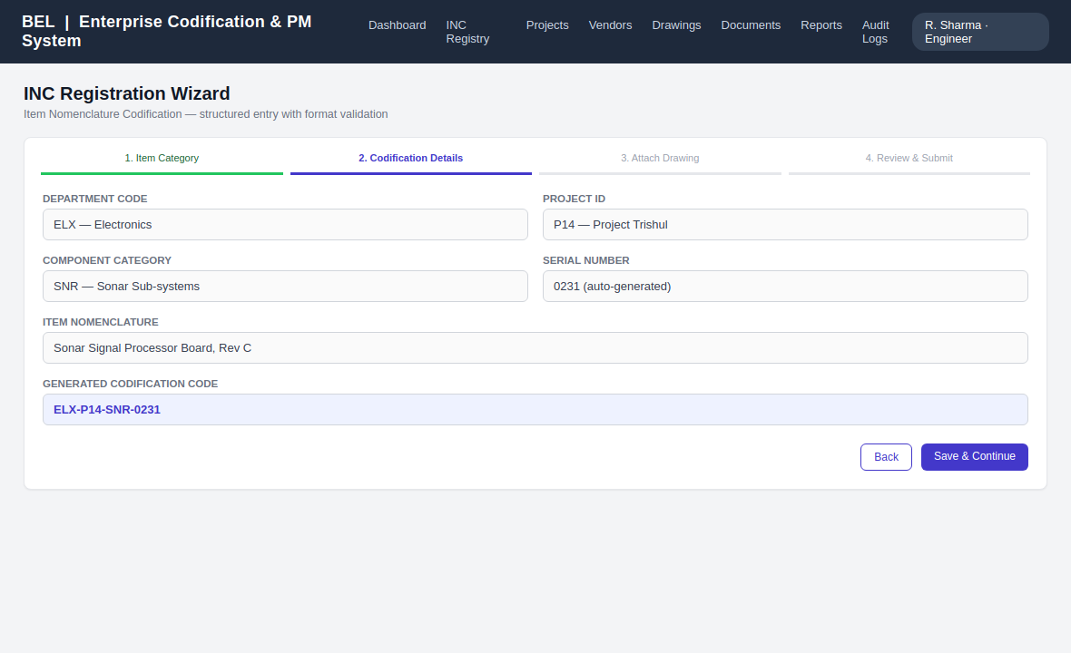
Fig. 28.1 — INC Registration Wizard (Step-by-Step Form with Format Checks)

29. PROJECT MANAGEMENT MODULE
The Project Management module tracks timelines, milestones, and component costs across active engineering projects.
It connects individual parts and assemblies directly to specific project profiles, giving project management offices real-time visibility into baseline schedules, current delays, and actual cost balances versus projected targets.
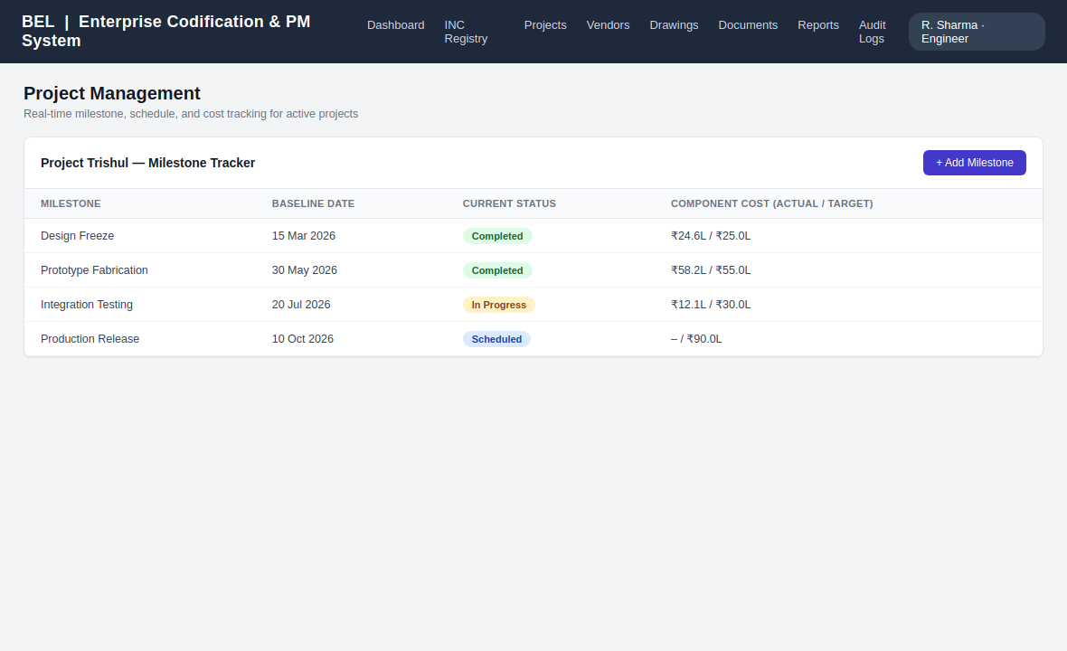
Fig. 29.1 — Project Tracking Panel (Milestones and Component Cost Indicators)

30. VENDOR MODULE
The Vendor Module tracks external supplier allocations, performance rankings, and certified delivery scopes.
The system stores vendor registration codes, quality control certifications, and component lists, making it simple to audit external supplier compliance and trace parts directly back to their source during quality reviews.
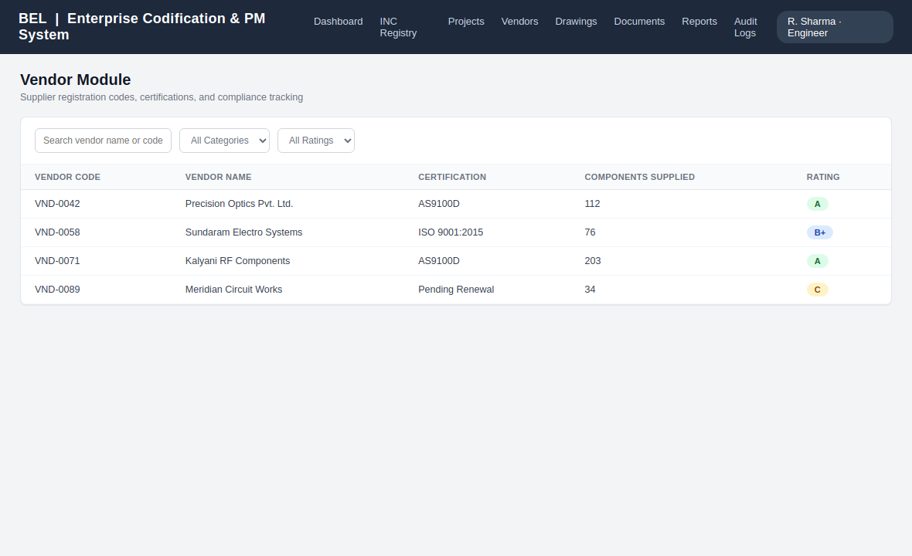
Fig. 30.1 — Vendor Profiles Interface (Supplier Records and Performance Indicators)

31. DRAWING MODULE
The Drawing Module provides version control and secure storage for technical CAD models and mechanical layouts.
It handles file additions through the multer storage engine, renaming files securely and locking down active engineering designs to ensure production floors work exclusively from authorized revisions.
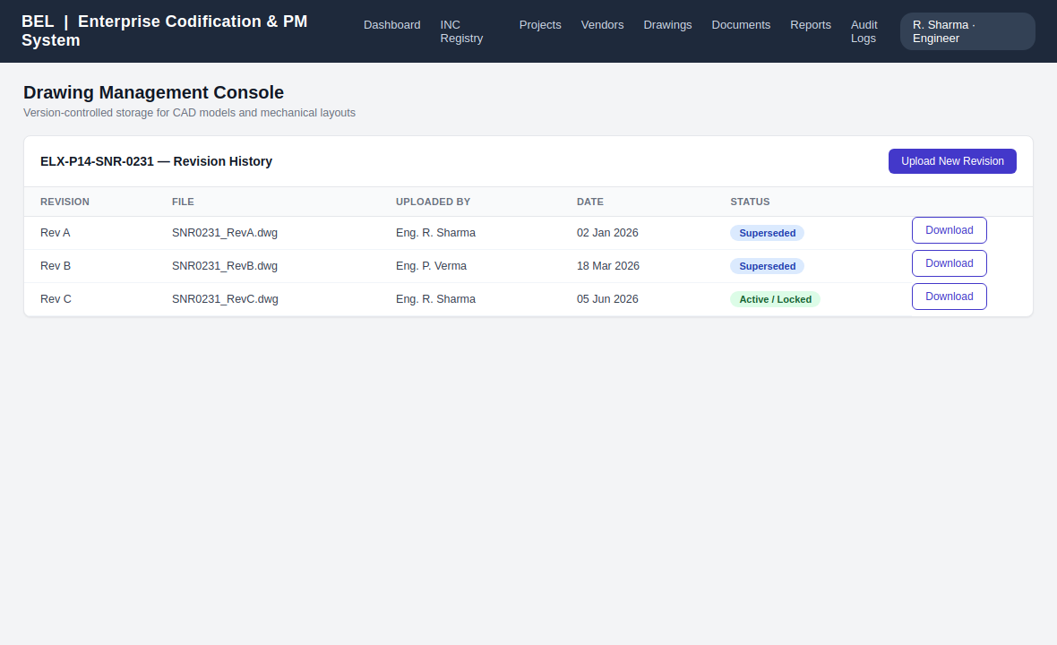
Fig. 31.1 — Drawing Management Console (Revision History and Download Selectors)

32. DOCUMENT MODULE
The Document Module handles the collection, indexing, and storage of compliance certificates, quality standards, and technical specifications.
All uploaded files are saved to an isolated server directory with randomized filenames, while matching metadata is written to the database to ensure files can be easily searched and securely retrieved.
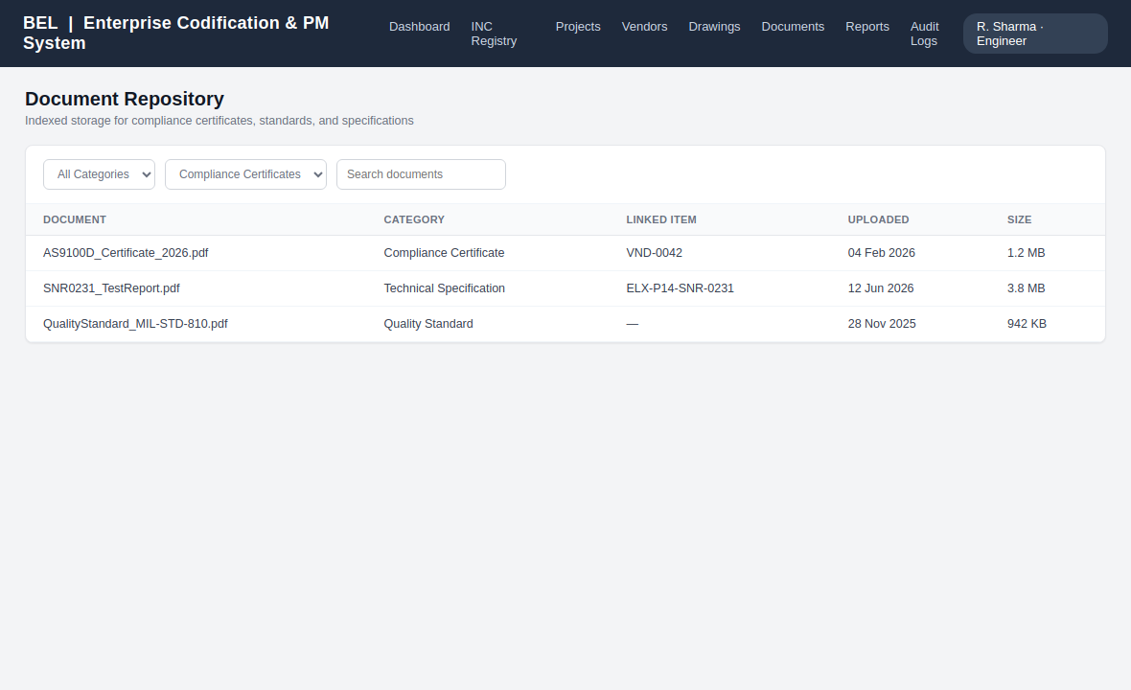
Fig. 32.1 — Document Repository Interface (Category Filters and File Metadata Records)

33. SEARCH MODULE
The Search Module allows users to find items across the entire repository using complex, multi-field queries.
The system indexes searches across component codes, names, project categories, and vendor references simultaneously, delivering rapid results even when working with extensive enterprise datasets.
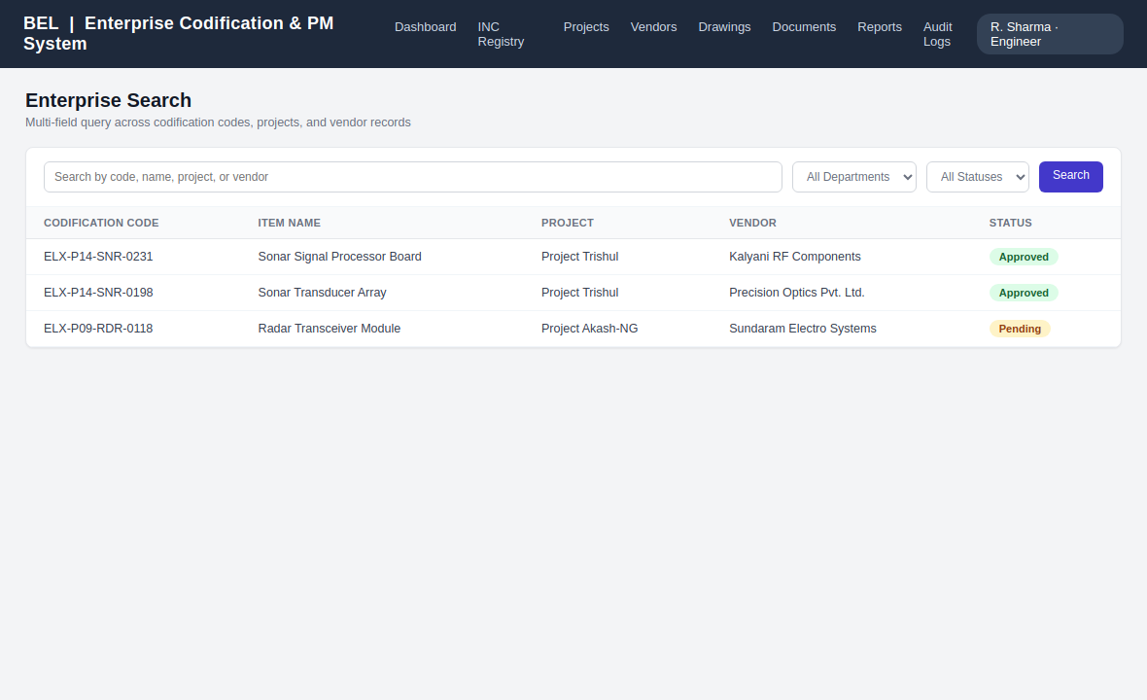
Fig. 33.1 — Enterprise Search Interface (Advanced Query Fields and Live Data Tables)

34. REPORTS MODULE
The Reports Module generates clear summaries of inventory levels, project progress, and system updates for internal audits.
It includes built-in streaming tools that allow users to export data directly to Excel sheets or formatted PDF files, ensuring external compliance reviews have access to clean, readable documentation.
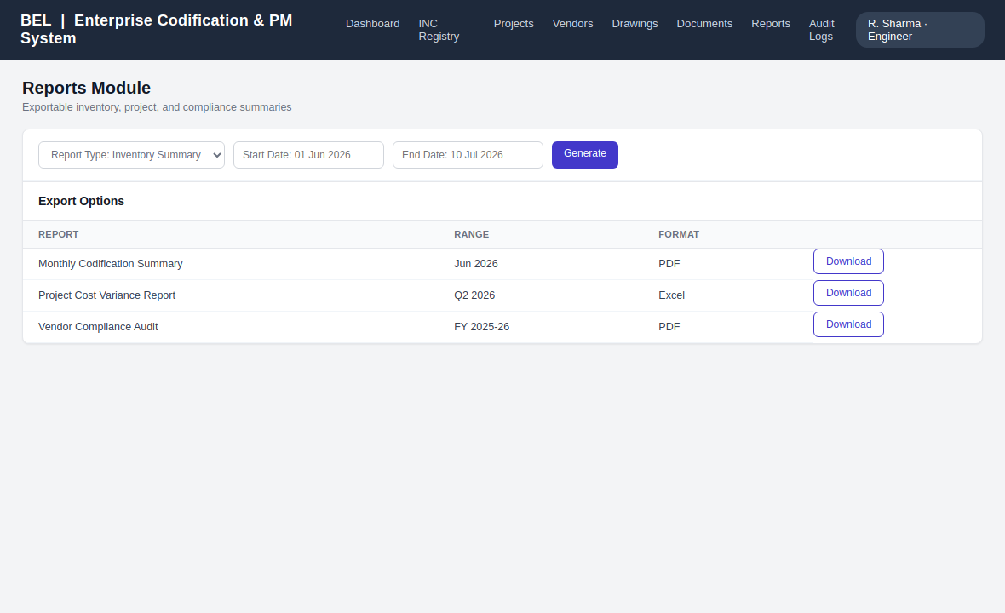
Fig. 34.1 — Reports Generator (Date Range Selectors and Data Export Options)

35. AUDIT MODULE
The Audit Module tracks all system activity, creating an unalterable log of user logins, data changes, and file access history.
Every event log records the user's ID, the action taken, their IP address, and an exact timestamp, providing clear accountability and security visibility across all application layers.
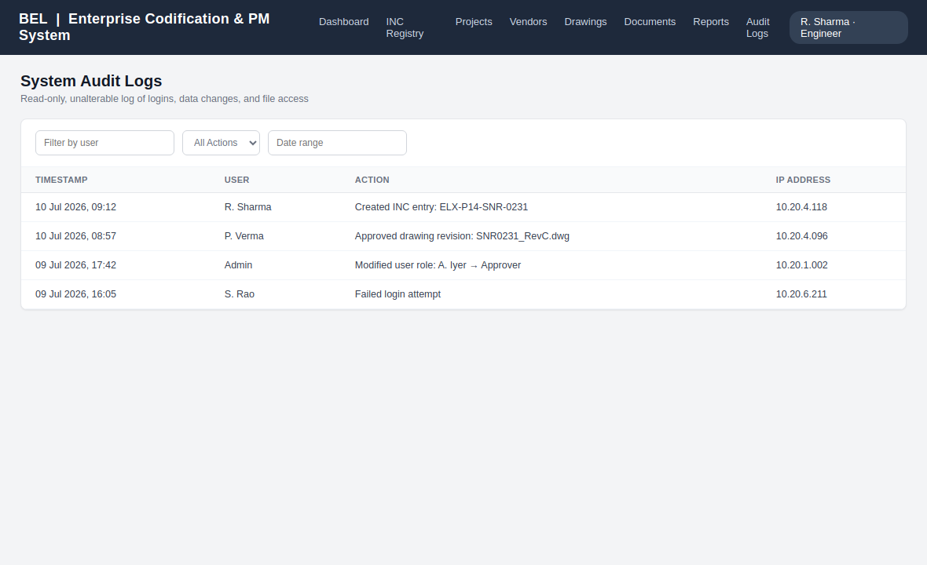
Fig. 35.1 — System Audit Logs Interface (Read-Only Data Grid with Filter Controls)

36. NOTIFICATIONS
The Notifications module keeps teams aligned by providing instant updates on validation states, pending reviews, and change requests.
The application updates user dashboards automatically when new tasks arrive, ensuring project managers and review teams can coordinate and respond quickly to process changes. Notification badges appear against the relevant module (INC Registry, Drawings, Approvals) in the top navigation bar, and a lightweight polling mechanism refreshes the pending-count indicators without requiring a full page reload.

37. SECURITY FEATURES
The application uses multiple security layers to protect internal defense data and maintain system stability:
- SQL Injection Prevention: All database interactions use prepared statements and parameterized inputs, blocking malicious query injections.
- Cross-Site Scripting (XSS) Mitigation: User inputs are systematically escaped and sanitized prior to browser rendering, preventing unauthorized script execution.
- Granular Route Access: Explicit middleware checks validate user clearance levels before routing requests, keeping sensitive administrative tools locked down.
- Session Integrity: Express Session cookies are marked HttpOnly and scoped to the intranet domain, reducing exposure to client-side script access.
- Password Hashing: All credentials are hashed with bcryptjs (salt work factor 10) before persistence; plaintext passwords are never stored or logged.

38. API DESIGN
The application uses an internal RESTful API design to handle data communication between the client interface and the backend server. Key endpoints are detailed below:

38.1 Authentication Endpoints
- POST /api/v1/auth/login — Processes user credentials and starts an authorized session.
- GET /api/v1/auth/logout — Formally ends the session and clears client session cookies.

38.2 INC Management Endpoints
- GET /api/v1/inc/list — Fetches a list of registered items based on search parameters.
- POST /api/v1/inc/create — Saves a new component record to the repository.
- PUT /api/v1/inc/:id — Updates an existing INC record pending re-approval.
- GET /api/v1/inc/:id/history — Returns the revision and approval history for an item.

38.3 Project & Vendor Endpoints
- GET /api/v1/projects/:id/milestones — Retrieves milestone and cost-tracking data for a project.
- POST /api/v1/vendors/create — Registers a new vendor profile with certification metadata.
- GET /api/v1/vendors/:id/components — Lists components traceable to a specific vendor.

38.4 Drawing, Document & Reporting Endpoints
- POST /api/v1/drawings/upload — Uploads a new CAD revision via the multer storage engine.
- GET /api/v1/documents/search — Performs indexed lookup across compliance documents.
- GET /api/v1/reports/export — Streams a generated report as an Excel or PDF file.
- GET /api/v1/audit/logs — Returns filtered, read-only audit trail entries.

39. FRONTEND DESIGN
The user interface is built using Bootstrap 5 to create a clean, responsive layout that displays properly across multiple office workstations.
The styling balances modern usability with clear data presentation, using a fixed navigation bar for quick access to key modules and styling layouts with clean CSS to keep data dense and readable. Consistent color coding (green for approved, amber for pending, red for rejected) is applied across all modules so users can scan status at a glance.

40. BACKEND DESIGN
The backend logic runs on Node.js using an Express server, organizing application code into clean controllers, routers, and database models.
The configuration settings are kept isolated in a secure .env file, while database connections are managed via an optimized pool instance to ensure quick response times and efficient query handling under heavy use.

41. TESTING METHODOLOGY
The validation process combined thorough unit checks, integration testing, and system-wide verification sweeps across all application components.
Unit testing verified individual controller routines, integration testing checked data flows between routers and the database, and system testing confirmed that permission levels and security boundaries were enforced correctly.

42. TEST CASES
The testing phase followed a structured validation suite to confirm all core operations performed correctly under standard and edge-case conditions:
Test ID | Module Checked | Input Scenario | Expected Result | Status
TC-001 | Authentication | Valid active username with matching password. | Initializes session, forwards to dashboard. | Passed
TC-002 | Authentication | Invalid password string against valid username. | Blocks access, displays verification alert. | Passed
TC-003 | INC Coding | Duplicate codification sequence entry. | Database rejects row, returns duplication error. | Passed
TC-004 | Access Control | Employee attempting to load administrative log views. | Middleware blocks request, returns 403 Forbidden. | Passed
TC-005 | Drawing Module | Upload of a revised CAD file for a locked drawing. | Creates new revision entry; previous version marked superseded. | Passed
TC-006 | Reports Module | Export request for a date range with no matching records. | Returns an empty, correctly formatted report file. | Passed

43. RESULTS AND OBSERVATIONS
The completed application provides a stable, unified transaction environment that successfully replaces manual tracking spreadsheets across the engineering division.
Database queries execute efficiently across normalized tables, and the interface scales cleanly under simulated multi-user request loads, keeping data views synchronized across all open dashboards.

44. ADVANTAGES
- Eliminates Part Duplication: Centralized validation checks stop duplicate items from being added, reducing procurement overhead.
- Clear Version Visibility: Integrated version tracking ensures teams work exclusively from the latest authorized engineering drawings.
- Complete Operational History: Read-only system logs capture every data update, providing full accountability for security reviews.

45. LIMITATIONS
- No Live CAD Rendering: The drawing module stores and tracks version history for CAD blueprints but cannot render raw 3D files directly in the browser interface.
- Intranet Dependency: Designed strictly for internal enterprise network configurations, requiring an active corporate network connection to function.

46. FUTURE SCOPE
Planned updates focus on integrating advanced analysis features and deeper automation tools into the existing core architecture:
- Automated CAD Parsing: Adding tools to automatically scan uploaded engineering drawings and generate initial Bill of Materials (BOM) entries.
- Advanced Search Integration: Adding full-text search engines like Elasticsearch to allow rapid indexing of text contents within scanned PDF attachments.

47. CONCLUSION
The BEL Enterprise Codification & Project Management System successfully delivers a secure, centralized web application that streamlines core engineering and project workflows.
By moving away from isolated spreadsheets and establishing a normalized database backend, the platform ensures complete data consistency, provides clear operational history, and maintains strong role-based security boundaries. The final application fulfills all target requirements, providing an institutional-grade platform ready for deployment within an enterprise infrastructure.

48. REFERENCES
[1] R. Elmasri and S. B. Navathe, Fundamentals of Database Systems, 7th ed. Boston, MA: Pearson, 2016.
[2] M. Haverbeke, Eloquent JavaScript: A Modern Introduction to Programming, 3rd ed. San Francisco, CA: No Starch Press, 2018.
[3] D. Flanagan, JavaScript: The Definitive Guide, 7th ed. Sebastopol, CA: O'Reilly Media, 2020.
[4] Bharat Electronics Limited, "Corporate Operational Overview and Strategic Technical Systems Framework," Internal Reference Material, 2024.

49. APPENDIX
Sample Controller Logic: incController.js
/**
* Controller managing the generation and persistence of new INC Master records.
* Validates role permissions and updates corporate records securely.
*/
const db = require('../config/database');

exports.createIncEntry = async (req, res) => {
const { codificationCode, nomenclature, projectId, vendorId } = req.body;
const userId = req.session.userId;

if (!codificationCode || !nomenclature || !projectId) {
return res.status(400).json({ success: false, message: 'Required fields missing.' });
}

try {
await db.query('START TRANSACTION');

const insertQuery = `
INSERT INTO inc_master (codification_code, item_nomenclature, project_id, vendor_id, approval_status)
VALUES (?, ?, ?, ?, 'Pending')
`;
const [result] = await db.query(insertQuery, [codificationCode, nomenclature, projectId, vendorId]);

const logQuery = `
INSERT INTO audit_logs (user_id, action_performed, ip_address)
VALUES (?, ?, ?)
`;
await db.query(logQuery, [userId, `Created INC entry: ${codificationCode}`, req.ip]);

await db.query('COMMIT');
return res.status(201).json({ success: true, message: 'INC Record created successfully.' });
} catch (error) {
await db.query('ROLLBACK');
return res.status(500).json({ success: false, message: 'Database error occurred.' });
}
};

